ENTREPRENEURSHIP DEVELOPMENT CELL

Name of the event: EDC Food Stall

Date: 7th September 2015- 8thSeptember 2015

Start Time: 9:00am
End Time: 4:00pm

AIM:

The basic aim for keeping this food stall was that members could identify their inner talent and use their talent in every which way possible.
It was a task where team communication and coordination was important.
The stall was kept for two days in our college.

GROUNDWORK:

To organise the entire food stall following groundwork involved was:
- The idea was approved in the meeting.
- Then permission for keeping the stall was arranged and approved.
- Then what items we were going to sell were discussed with the EDC members,
and accordingly materials were arranged for the same.
- To build the marketing skills, every member were taught how to sell our food items to students in the college premises.
- Every members had 4 people in a group and Students director had made 4 groups for handling the stall where the will work according to shifts.

SUMMARY:

DAY 1:-

- EDC Food stall started at 9:00am
- EDC members decided that they will sell Sukha Puri, Chinese bhel, Vada Pav and Jaljeera.
- Then various food items required were arranged by the EDC members.
- Core members decided that they will sell Sukha Puri for Rs 25/- , Chinese Bhel for Rs 20/-, Vada Pav for Rs 10/- and Jaljeera for Rs 10/-.
- EDC had also kept mehndi during the stall.
- Every team members were taught how to make Sukha Puri and Chinese Bhel.
- Then members were instructed as to how to do the PR for the food stall.
- Photographs for our food stall were clicked.
- Professor Anita Agarwal was invited for our food stall.
- EDC team made good profit from the food stall.
- There was a high demand for Chinese Bhel and Jaljeera.
- But EDC team decided to keep only Chinese bhel for 2nd day and not Jaljeera
because they were trying to bring up some innovative food item that they were
going to sell.
- Food Stall got closed at 4:00pm
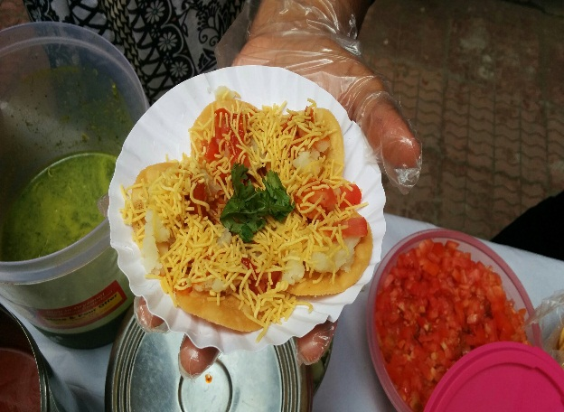
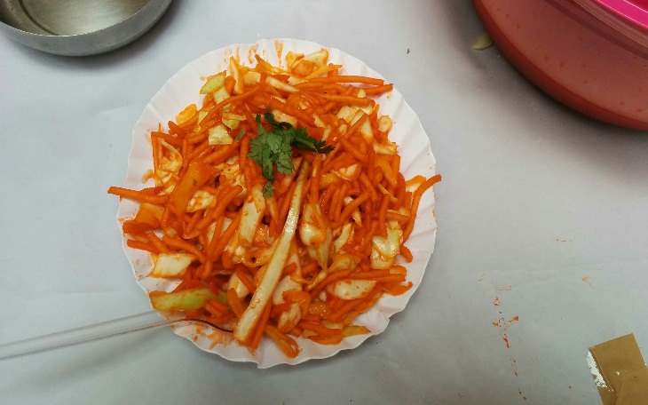

DAY 2:-

- EDC Food stall started at 9:00am
- EDC members decided that they will sell Chinese bhel, Sev Puri and lemonade.
- Then for the making of various food items EDC members had made arrangements for it.
- Core members decided that they will sell Sev Puri for Rs 25/- , Chinese Bhel for Rs 20/-, and lemonade for Rs 10/-.
- Every team members were taught how to make Sev Puri and Chinese Bhel.
- Then members were instructed as to how to do the PR for the food stall.
- Photographs for our food stall were clicked.
- Professor Anita Agarwal again visited to try out our new food items
- Professor Pallavi Rege came to see our food stall.
- EDC team made good profit from the food stall.
- There was still high demand for Chinese Bhel.
- EDC stall was closed at 4:00pm
The event went very well and was brilliantly executed by the organising team and all the members of Entrepreneurship development cell.

